

Pentaho Data Integration
version 3.0

Making a fresh start

Key differences with version 2.5.0
List of changes on November 12th 2007

Compiled by Matt Casters, mcasters (at) pentaho.org
Send additional changes you found to this address.

Index
1. Changes summary 3
1.1. Preface 3
1.2. Overview 4
2. General changes 6
2.1. New core API 6
2.1.1. Data and meta-data split 6
2.1.2. Lazy conversion 7
2.2. Improved preview and debug 8
2.3. Revised Spoon GUI 9
2.3.1. New icons 9
2.3.2. Customization of Spoon 10
2.4. Mappings on steroids 10
2.5. New steps 12
2.5.1. CSV Input 12
2.5.2. Fixed Input 12
2.5.3. Access Input 13
2.5.4. LDAP Input 13
2.5.5. Append streams 14
2.5.6. Abort 14
2.5.7. Regex Evaluation 14
2.5.8. Mondrian Input 14
2.5.9. Closure generator 15
2.5.10. Get files rows count 15
2.6. New Job entries 16
2.6.1. XSL transformation 16
2.6.2. Success 16
2.6.3. XSD validator 16
2.6.4. DTD validator 17
2.6.5. Write to log file 17
2.6.6. Copy files 18
2.6.7. Put a file with FTP 18
2.6.8. Unzip files 19
2.7. Databases 20
3. Source code improvements 21
3.1. A few extra lines of code 21
3.2. Core committers 21
3.3. Commit stats 22
3.4. Feature requesters 22

Changes summary

Preface
Creating Pentaho Data Integration version 3.0 was a challenge in all meanings of the word. When you start the new and improved Spoon version, you will notice the new icons look. However, the changes that went on in the core API have been much bigger than what meets the eye on the first glance.
At a certain point during development you come to the realization that certain aspects of the existing software design is not turning out quite the way you wanted or envisioned at the start. This realization is at the core of most evolutions in software development and certainly also for PDI 3.0. We tried to get rid of every bottlenecks and inconsistency we could think of. Now that we in fact did get rid of those, we believe that in the future we'll be able to evolve even faster than we already do.
In this release we've again managed to attract more and more people in the community to help out with coding, documentation, translation, packaging (w32 installer), bug reporting and many things more. This document was written as a special “thank you” note to all those people involved and to keep everyone informed about the enormous progress we are making.

Overview
These are the most notable changes that have been made:
- New core API
- Split of data and meta-data offering greater flexibility and performance
- Centralized data conversion API with accurate and enhanced error reporting
- Simplified and unified preview and debug architecture (with listeners)
- Advanced data storage engine
  - Normal storage: native data types (as before)
  - Binary string storage: for lazy conversion (see below)
  - Indexed storage: references a table of contents. The data is a simple integer index.
- Improved step and job plug-in system with annotations:
  - http://wiki.pentaho.org/display/EAI/Annotated+step+plugin+development

- Improved transformation preview and debug
- Preview with “Get more rows” functionality.
- Transformation start, pause, resume, stop
- Debugger with conditions (breakpoint pause)

- New high performance text file handling
- Lazy conversion helps to prevent String data conversion when it's not really needed
- New high performance “CSV Input” step with Non-blocking IO (NIO) support
- New high performance “Fixed Input” step with NIO and parallel reading support

- Revised Spoon GUI
- New set of icons with consistent color scheme.
- First steps towards full XUL support (Menu, Tool bar, ...)
- Created more possibilities for Spoon customization (OEM) of look and feel

- Mappings on steroids
- Allows zero or more input streams
- Allows zero or more output streams
- Can be parameterized using variables
- Supports global field renames on input and output

- Other new Steps
- Access Input : reads MS-Access MDB files directly.
- LDAP Input: reads information from an LDAP server
- Append streams: append 2 streams in an ordered way
- Abort: abort a transformation in case one or more rows are read
- Regex Evaluation : evaluate regular expressions
- Mondrian Input : read data from a Mondrian server using MDX
- Closure generator: generates transitive closured for use with Mondrian.
- Get files rows count : count the number of rows in files

- New Job entries
- XSL transformation : to transform XML documents
- Success : to force success on a job after failure
- XSD validator : validate an XML document using XSD
- DTD validator : validate an XML document using DTD
- Write to log file : write a message in the log file
- Copy files : copies one or more sets of files from one location to another
- Put a file with FTP
- Unzip files

- Miscellaneous
- Hundreds of issues fixed and features implemented (400+)
- A new translator GUI (French translation is now complete)
- A new software package for our OSX users
- Put a new bug tracking system into action: http://jira.pentaho.org/browse/PDI
- Adding more and more content to our PDI Wiki documentation site.
- ...

General changes

New core API

Data and meta-data split
One of the notable changes is a redesign of the internal data engine.
More to the point, we now have a strict separation of data and meta-data.
The main reason for doing so was the reduction of object allocation and also to allow us to extend the meta-data in this release and in the future without even the slightest performance impact.
We anticipated a performance gain here and there, and initial test-code gave us a 15-20% increase in performance to hope for. What we have seen is a performance gain that is quite a bit higher than that. To measure the performance gain we made a library of test-cases to run performance and regression tests again version 2.5 code. The result with comparison (speedup calculation) is posted here.
One of the nice things about the code changes is that although it will break the API, it’s a Good Think(TM) for the project in the long run. It will give us breathing room to keep innovating in the future:
- Select Values : x9 (Random select), x6 (Delete field), x5.5 (Change metadata)
- Calculations: between x1.8 and 3.6 faster
- Add sequence : up to 3x faster
- Table Output : 15% faster up to x2
- Add constant values: x5
- Filter rows: x1.5
- Row generator: x2.5 - x3 (up to 1.2M empty rows/s)
- Sort rows: x1.15 - x5
- Stream Lookup: x1.24 - x1.36 (and this step already got some serious tuning in the past)
- Table Input: x1.2
- Text File Input: x1.6 - x3.4
- Text File Output: x1.75 – x2.9
- ...
On top of that, memory usage should have been reduced as well.
Besides this we also cleaned up the data conversion algorithms. This has consequences in certain extreme cases. For a complete list of things to look out for during migration, go to our migration guide:
http://wiki.pentaho.org/display/EAI/Pentaho+Data+Integration+3.0+migration+guide

Lazy conversion
In the specific case where we're reading text files and writing data back to text files, a lot of work is being done for nothing. First we convert data during file read:
- byte[] (in a file) to Java String (UTF-8)
- String to Date, String to Integer, String to Number, etc. using a certain mask
Then we do the exact opposite again when we write data back to file:
- Integer to String, Date to String, Number to String, etc using a certain mask
- Java String (UTF-8) back to byte[]

These conversions are not trivial since they take into account code-page conversions, locality, masks, decimal point and grouping symbols and a lot more. As such they consume a lot of CPU.

So we used the concept of “Lazy Conversion” in PDI 3.0. Lazy conversion delays conversion of data as long as possible with the hope it might never occur at all. Obviously, in the case where you read from a text-file and write back to another one in the same format, conversion never occurs. In that particular case, we read bytes and dump them to file again without ever looking at the actual content. (unless we have to in case the conversion formats are different for example)

See also: http://www.ibridge.be/?p=63 for more details and http://www.ibridge.be/?p=78 for a use-case.

Improved preview and debug
If you select one or more steps and select preview from the tool bar or menu, you will be presented with this transformation debug dialog:
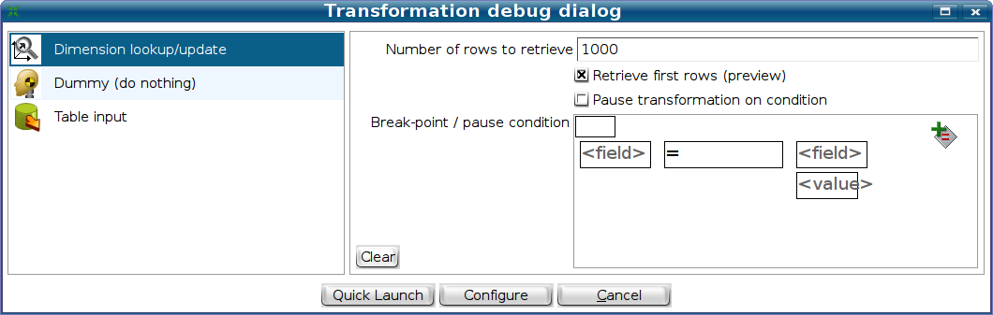

A configurable default number of rows to preview will be set on the selected steps. Hitting the “Quick launch” button will start the transformation in preview mode.
When the rows to preview are found for a certain step, they will be immediately shown in a dialog. You can there and then opt to get more rows to preview:
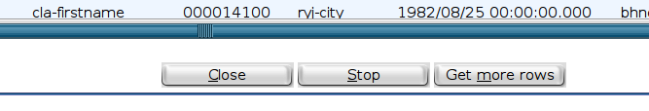

If you just close the dialog, the transformation will be in a paused state and can then be resumes from the transformation log window. (getting more rows to preview)
If you use the debug button, we will set different parameters on the selected steps:
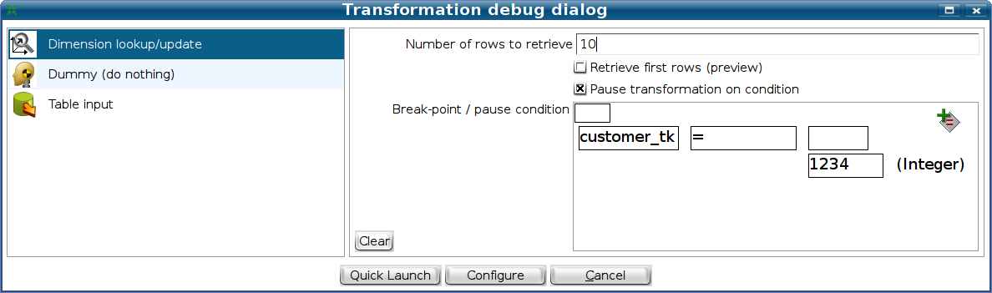

The condition can then be used to pause the transformation when a certain condition is met. In the example above we want to pause the transformation if we retrieve technical key “1234” in a dimension. Not only that, we want to see the last 10 records that passed through the step. When this record is found, it will be shown together with the other 9 requested in reversed order:
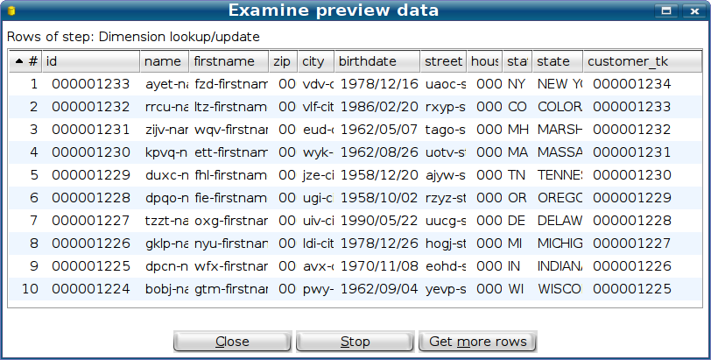

Revised Spoon GUI

New icons
The excellent icons below where created by the Pentaho Pixel Manager and are the first thing you notice when you create new transformations or jobs or re-open your existing files.
 |  |  |  |  |  |  |  | 
 |  |  |  |  |  |  |  |  | 
 |  |  |  |  |  |  |  |  | 
 |  |  |  |  |  |  |  |  | 
 |  |  |  |  |  |  |  |  | 
 |  |  |  |  |  |  |  |  | 
 |  | 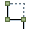 |  |  |  |  |  | 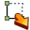 | 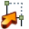
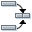 |  |  |  |  |  |  |  |  | 
 |  |  |  |  |  |  |  |  | 
 |  |  |  |  |  |  |  |  | 
 |  |  | 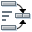 |  |  |  |  |  | 
 |  |  |  |  |  |  |  |  | 
 |  |  |  |  |  |  |  |  | 
 |  |  |  |  |  |  |  | 

Customization of Spoon
Version 3.0 of PDI allows you to configure Spoon to your taste. This was mostly done to make it easier to OEM the GUI elements. To do this, it must be possible to change icons, messages, colors and fonts without the need for any change to the existing code.
One of the notable changes in directions we took was that we started to use XUL (http://www.mozilla.org/projects/xul/) to drive our menus and tool bars. This allows people to inject their own menu-items and create their own tabs in Spoon.
For those that want to go even further we created hidden XML files (inside the kettle jars) to change a lot of aspects of the software behavior.

Mappings on steroids
Mappings in the past where limited in use. We increased the number of possible use-cases by allowing the mappings to be a lot more complex than before. At the same time we added various features to make usability better than before.
For example, this mapping has 2 inputs and a single output:
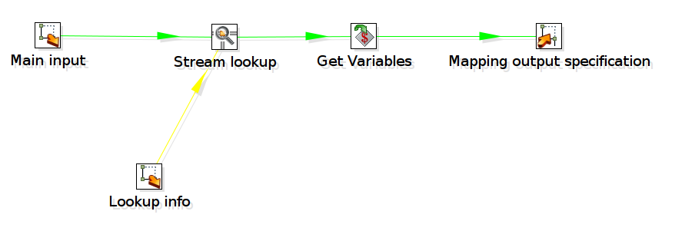

The mapping step to execute the transformation looks like this:
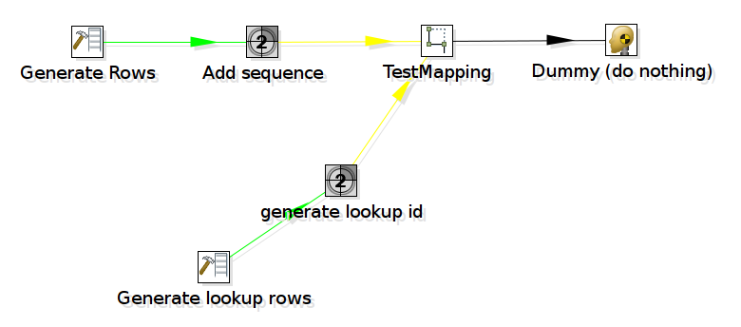

This is handled by the following mapping dialog:
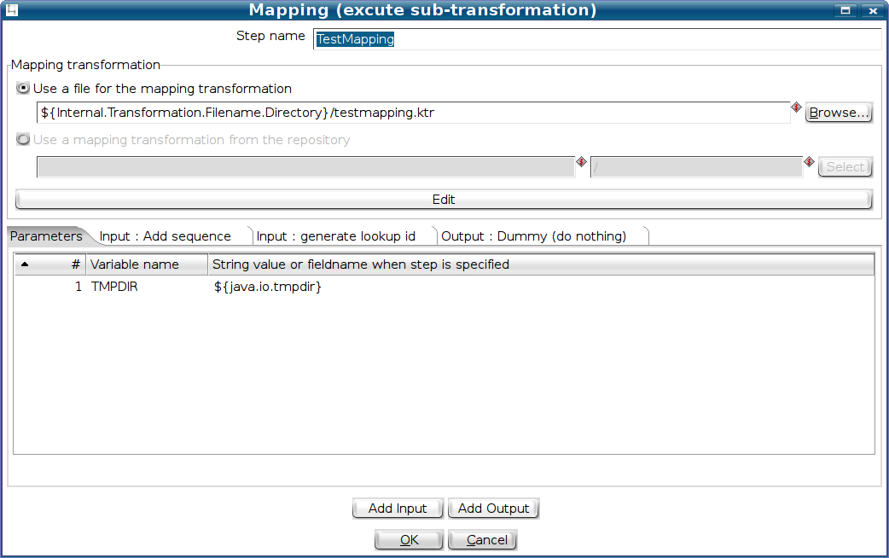

As you can see, there is a single tab created for every input or output stream you add and a single one to set the parameters on the mapping (sub-transformation).
The input and output tabs have several helper buttons to allow you to set up the mapping step as easily as possible:
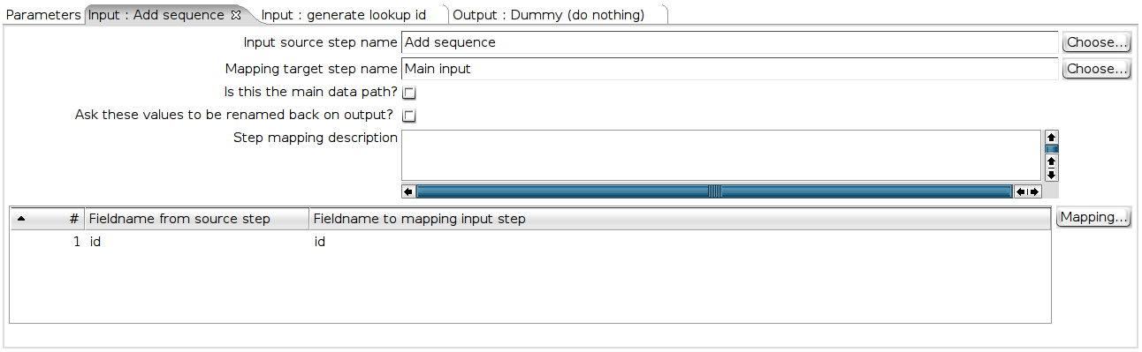

New steps
Below is an overview of the new steps that were added. For the full details on these steps, please consult the Spoon user guide documentation.

CSV Input
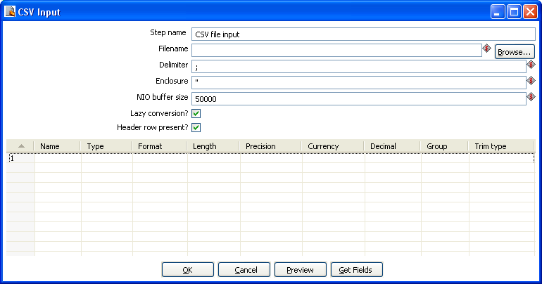
This step provides the ability to read data from a delimited file. It conforms to this CSV “standard” as much as possible: http://en.wikipedia.org/wiki/Comma-separated_values

Fixed Input
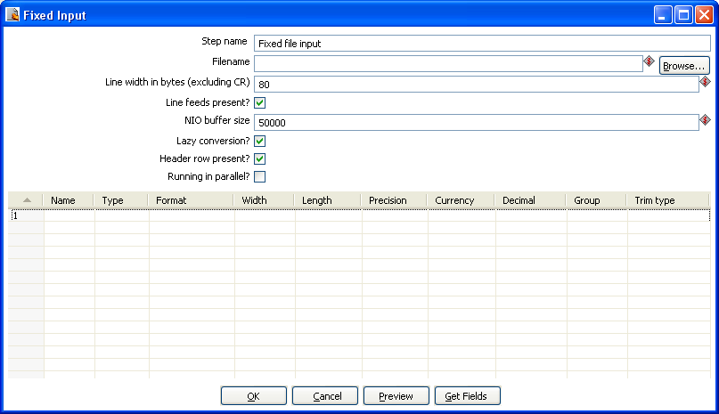
This step is used to read data from a fixed width file.

Access Input
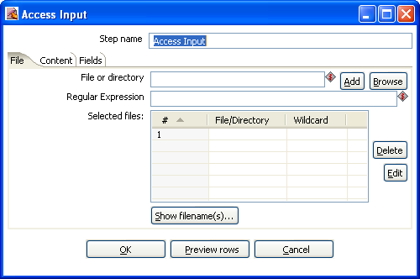
This step reads MS-Access MDB files directly.

LDAP Input
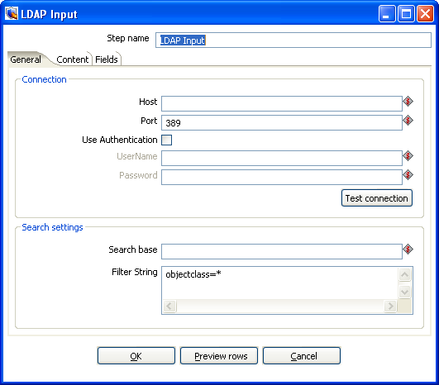
Reads information from an LDAP server

Append streams
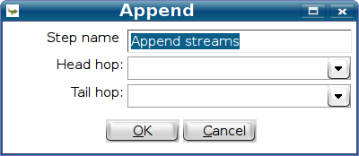
Appends 2 streams in an ordered way

Abort
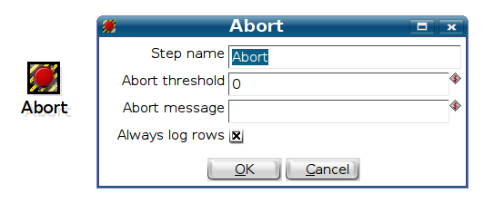
Aborts a transformation in case one or more rows are read on input.

Regex Evaluation
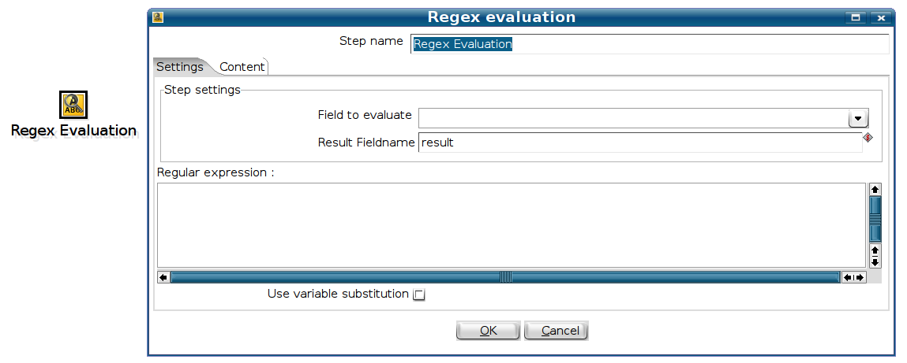
Evaluate (and substitute) using regular expressions.

Mondrian Input
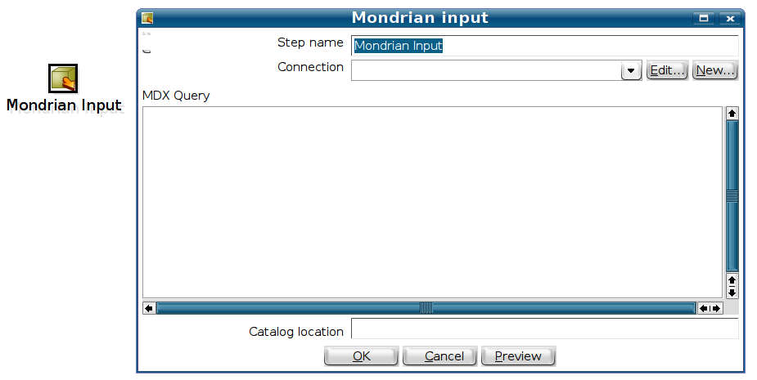
Read data from a Mondrian server using MDX.

Closure generator
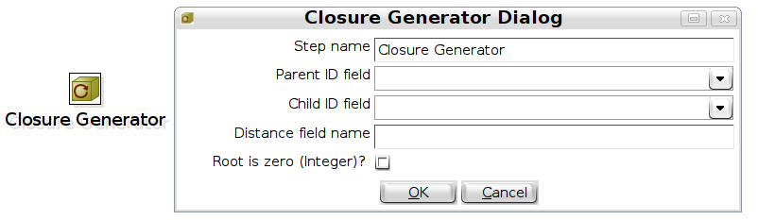
Generates transitive closured for use with Mondrian.
See also: http://wiki.pentaho.org/display/EAI/Closure+Generator

Get files rows count
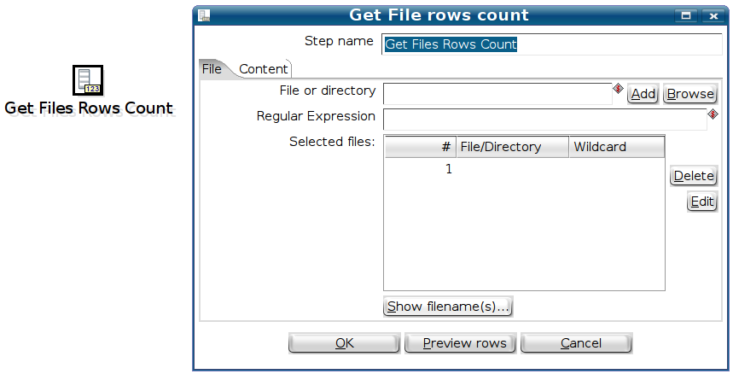
Count the number of rows in files.

New Job entries
Below is an overview of the new job entries that were added. For the full details on these job entries, please consult the Spoon user guide documentation.

XSL transformation
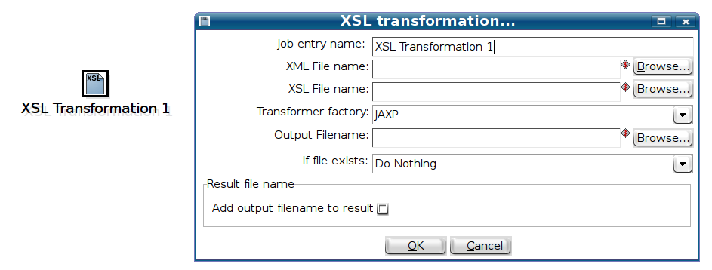
A job entry to transform XML documents using XSLT

Success
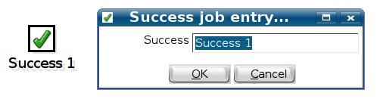
To force success on a job, for example after an expected failure

XSD validator
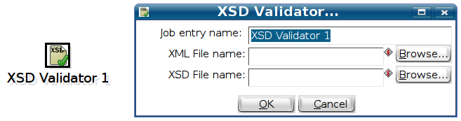
Validate an XML document using XSD

DTD validator
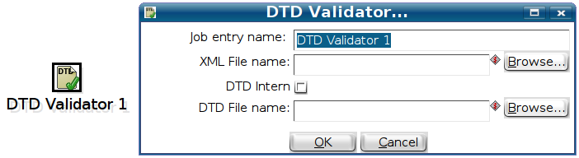
Validate an XML document using DTD

Write to log file
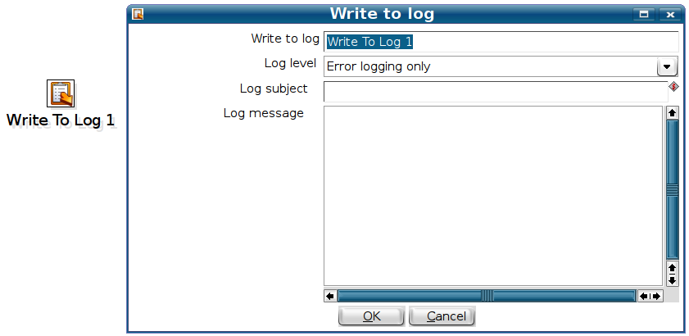
Write a message in the log file

Copy files
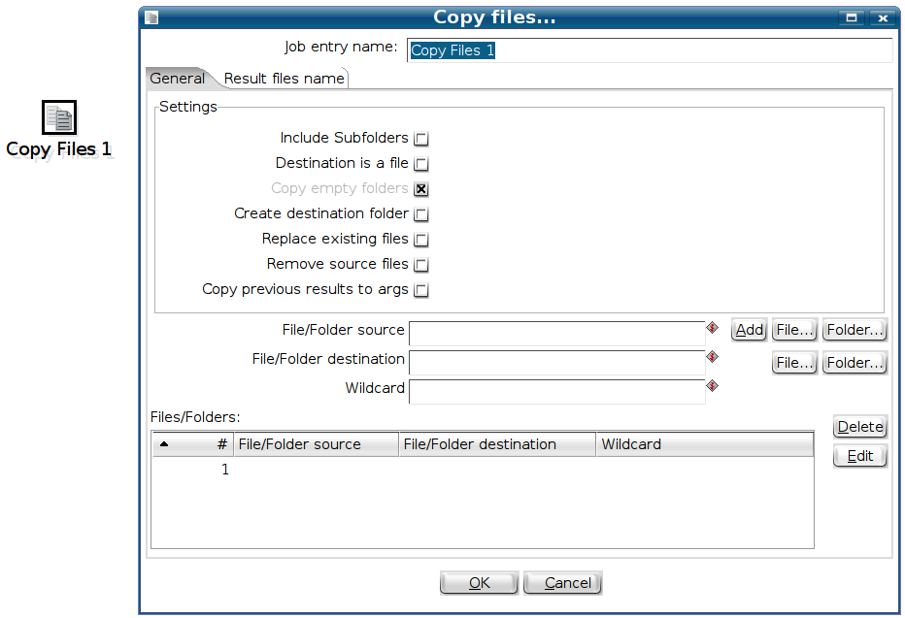
Copies one or more sets of files from one location to another

Put a file with FTP
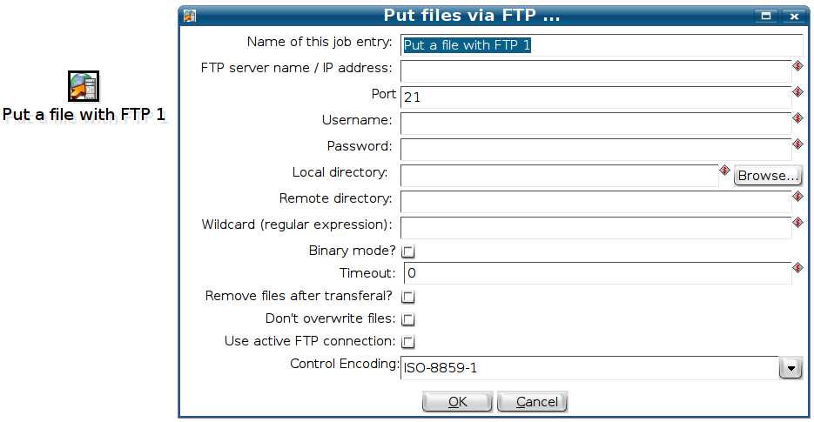
Allows you to transfer multiple local files to a remove FTP server.

Unzip files
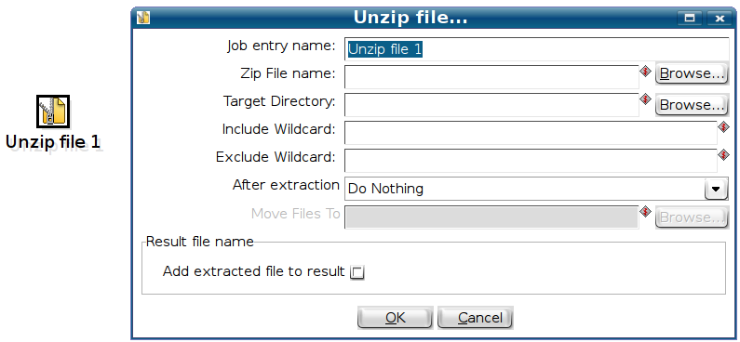

Databases
- We now also have a set of advanced options to steer the behavior of table and column (field) quoting:
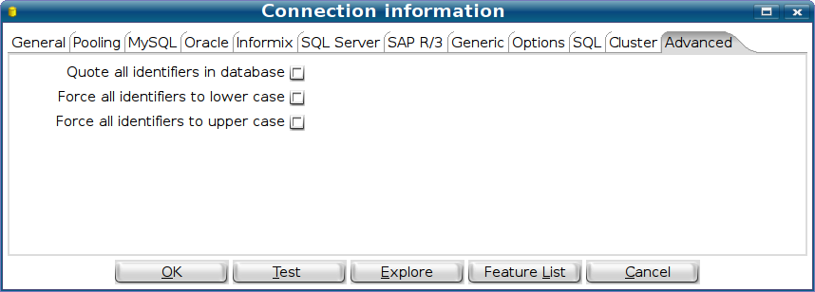
- Support was added for Apache Derby, BMC Remedy Action Request System and Sybase IQ.
- We added a PALO database placeholder for a set of plugins that will arrive soon. This is very much like we did for SAP/R3.

Source code improvements

A few extra lines of code
Version 2.1.4 contains 160,000 lines of code.
Version 2.2.2 contains 177,450 lines of code, an increase of 17,450 lines.
Version 2.3.0 contains 213,489 lines of code, an increase of 36,039 lines.
Version 2.4.0 contains 256,030 lines of code, an increase of 42,541 lines.
Version 2.5.0 contains 292,241 lines of code, an increase of 36,211 lines.
Version 3.0.0 contains 348,575 lines of code, an increase of 56,334 lines.

Core committers
Here is the list of all the people that helped to make version 3.0 happen. (not in any particular order!)
ID | e-Mail | Name | Country
sboden | Svenboden (at) hotmail.com | Sven Boden | B
jbleuel | Jens (at) pentaho.org | Jens Bleuel | D
Sven.thiergen | s.thiergen (a) itcampus.de | Sven Thiergen | D
shassan2 | Sahass78 (a) yahoo.fr | Samatar Hassan | F
molm | manfred.olm (a) free.fr | Manfred Sherlock Olm | F
hdupre | henri.dupre (a) gmail.com | Henri Dupre | F
asilva | asilva (a) pentaho.org | Alex Silva | US
jdixon | jdixon (a) pentaho.org | James Dixon | US
Brassrat | jgoldman (a) vestmark.com | Jay Goldman | US
mbatchelor | mbatchelor (a) pentaho.org | Marc Matchelor | US
mlowerly | mlowery (a) pentaho.org | Matthew Lowery | US
quinhui99 | qinhui99 (a) hotmail.com | Qin Hui (Tom Qin) | CH
wgorman | wgorman (a) pentaho.org | Will Gorman | US
dkincade | dkinkade (a) pentaho.org | David Kincade | US
mdamour | mdamour (a) pentaho.org | Mike D'Amour | US
gmoran | gmoran (a) pentaho.org | Gretchen Moran | US
bhagan | bhagan (a) pentaho.org | Brian Hagan | US
jtcornelius | jtcornelius (a) pentaho.org | Jake Cornelius | US
arodriguez | arodriguez (a) pentaho.org | Anthony Rodriguez | US
sbarkdull | sbarkdull (a) pentaho.org | Steven Barkdull | US
dmoran | dmoran (a) pentaho.org | Doug Moran | US
mcasters | mcasters (at) pentaho.org | Matt Casters | B

Because of the massive amount of commits (+2000) and as usual space and time constraints, it's very difficult to include a detailed commit log. It's also very hard to quantify the amount of work someone did as it is very clear that we appreciate all the help we get on this project.

Commit stats
In total we had in excess of 2000 revisions of the source code (commits).
All 1154 files in the subversion repository have been altered or re-created since we moved to a different package naming convention for Pentaho Data Integration. There isn't a single source code file that was not changed.
Bug reporters
Thank you all! Without you, it would be impossible to get PDI as stable as it is today.

Feature requesters
Thank you all for the many good suggestions! Sometimes the simple things have a great impact on the software. Good ideas really make the difference.

